

**Balloon**

**Electrical**

**Work**

Table of Contents

1 Power 3

1.1 Connector on Board 3

1.2 Battery 5

1.3 Buck Circuits 7

2 Prozessor 8

2.1 AtmegaXdXandel32 (some form of an Arduino) 8

2.2 Esp32 8

2.3 Raspberry Pi 8

2.4 Data Logging / Storage 9

3 Communication 10

3.1 Provided connector by the BEXUS Balloon 10

3.2 Radio frequencies 11

4 Sensors 12

4.1 Oxygen 12

4.2 CO2 13

4.3 Temperatur 13

5 Camara 14

5.2 VisiSense TD 15

5.3 colorimetric pH 16

5.4 indicators (e.g. phenol red) 16

6 Heating 16

6.1 General Konzept 16

7 Light 17

7.1 god i hope the sun is okay 17

7.2 alternatives 17

# Power

## Connector on Board

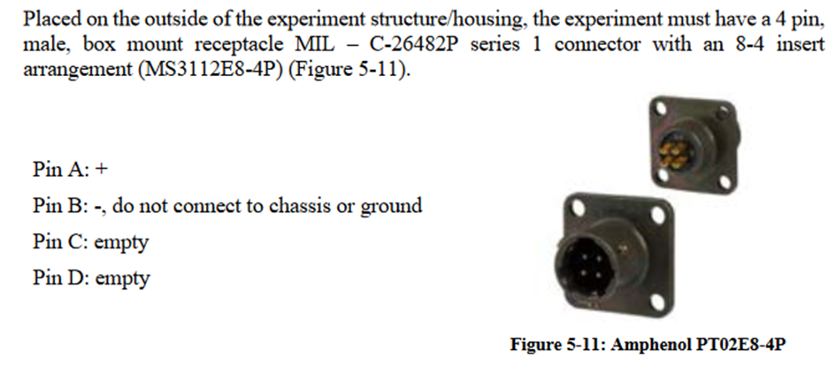

Table 4‑1: REXUS connector pin out usage.

|  |  |  |
| --- | --- | --- |
| **Pin No.** | **Name.** | **Use** |
| 1 | +28 V | Experiment Power |
| 2 | Charging (28 V/1 A) | Not connected – not used |
| 3 | SODS | Not connected – not used |
| 4 | SOE | Used |
| 5 | LO | Used |
| 6 | EXP out+ | Downlink (non-inverted) |
| 7 | EXP out- | Downlink (inverted) |
| 8 | 28 V Ground | Ground |
| 9 | +28 V | Experiment Power |
| 10 | n.c. | Not connected |
| 11 | n.c. | Not connected |
| 12 | Charging Return | Not connected – not used |
| 13 | EXP in + | Uplink (non-inverted) |
| 14 | EXP in - | Uplink (inverted) |
| 15 | 28 V Ground | Ground |

## Battery

With the recommended maximum peak current draw of 1.8A the battery lasts about 4h, but realistically more like 3.

To fit in the recommended 10h battery life we should draw not more than 690mA so a bit under 20W.

## Buck Circuits

# Prozessor

## AtmegaXdXandel32 (some form of an Arduino)

Pro:

* Cheap (2-15€)
* Reliable
* Small
* Very Easy to program / troubleshoot
* Nearly no energy consumption

Cons:

* Camera if even possible very low quality and no live stream
* Ethernet stream difficult
* Limited Computing Power might become a problem

We are not part of the cool kids

## Esp32

Like a bit faster Arduino, but bit less reliable and less easy to program (for me). Only a difference with a camera.

## Raspberry Pi

Pro:

* Strong Computing Power -> Camera & Stream = no problem
* Easy connections (USB, Ethernet included)

Cons:

* Bit harder to program and troubleshoot
* Bigger
* Draws a lot of power (from around 2W idle till 5W peak), maybe can be used as heating?
* Bit less reliable

We are part of the cool kids

## Data Logging / Storage

# Communication

## Provided connector by the BEXUS Balloon

## A screenshot of a computer Description automatically generatedRadio frequencies

# Sensors

## Oxygen

Ein Bild, das Text, Screenshot, Kreis enthält.
Gravity: I2C Oxygen Sensor

Current price €51,10

The Gravity: I2C Oxygen Sensor is based on electrochemical principles and it can measure the ambient O2 concentration accurately and conveniently. With high anti-interference ability, high stablility and high sensitivity, this arduino-compatible oxygen sensor can be widely applied to fields like portable device, air quality monitoring device, and industries, mines, warehouses and other spaces where air is not easy to circulate.  
  
This compact dfrobot oxygen sensor supports I2C output, it can be calibrated in the air, can accurately measure the oxygen concentration in the environmentit. It is compatible with many mainboards like Arduino Uno, esp32, Raspberry Pi and so on. Its effective range is 0~25%Vol, and resolution can reach to 0.15%Vol. It supports wide range input voltage: 3.3V to 5.5V.  
  
Moreover, the lifetime is as long as 2 years. With simple Gravity interface and practical sample code, you can build your own oxygen concentration monitor easily and conveniently.

<https://store.arduino.cc/products/gravity-i2c-oxygen-sensor>

Grove - Gas Sensor (O2)

Current price €56,12

You can see the current oxygen concentration from reading the voltage values output proportional to the concentration of oxygen on the oxygen concentration linear characteristic graph. It’s suitable for detecting oxygen concentration in the environment. Grove - Gas Sensor(O2) is an organic reaction module and it provides a small current in relation to the amount of O2 in the air, hence we don’t need to provide an external power.

<https://store.arduino.cc/products/grove-gas-sensor-o2>

## CO2

Gravity: Analog CO2 Gas Sensor (MG-811 Sensor)

SKU TPX00029 Barcode SEN0159 Show more

Current price €44,61

This is the first CO2 sensor compatible with Arduino. The output voltage of the module falls as the concentration of the CO2 increases. The potentiometer onboard is designed to set the threshold of voltage. As long as the CO2 concentration is high enough (the voltage is lower than the threshold),  a digital signal (ON/OFF) will be released.

* It has MG-811 sensor module which is highly sensitive to CO2 and less sensitive to alcohol and CO, low humidity & temperature dependency.
* Onboard heating circuit brings the best temperature for sensor to function. Internal power boosting to 6V for heating sensor best performance.
* This sensor has an onboard conditioning circuit for amplifying output signal.

<https://store.arduino.cc/products/gravity-analog-co2-gas-sensor-mg-811-sensor>

## Temperatur

# Camara

Thermal Camera a useful option?

Also there are rules for cameras pointing at the surrounding. Lets skip this and just not do that.

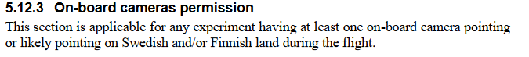

* + 1. GoPro
    2. Development Board

Depends strongly on the processor. If is a weak one:

Ein Bild, das Elektronik, Text, Elektronisches Bauteil, Elektrisches Bauelement enthält.

<https://www.berrybase.de/esp32-cam-development-board-inkl.-ov2640-kameramodul>

Ein Bild, das Text, Screenshot, Elektronik, Kreis enthält.

<https://www.marotronics.de/CMOS-Kamera-640-x-480-I2C-Interface-for-Arduino-OV7670>

If it’s a Raspberry Pi:

Ein Bild, das Text, Screenshot enthält.

<https://www.berrybase.de/raspberry-pi-high-quality-kamera-m12-mount?c=341>

## VisiSense TD

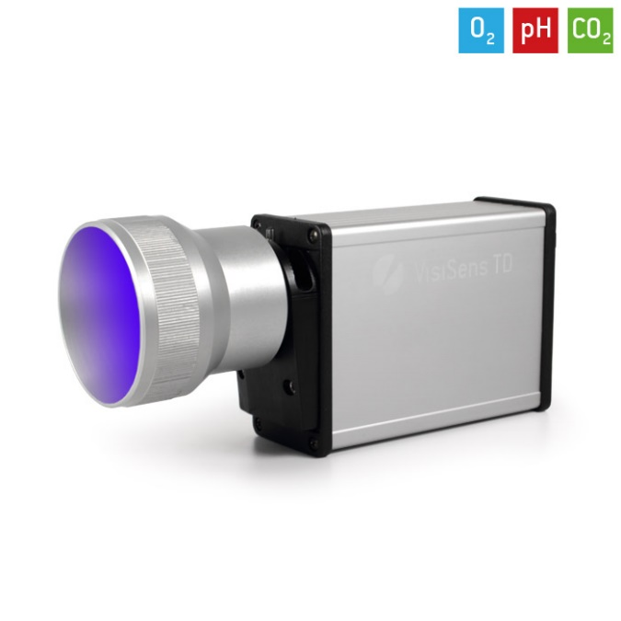2D-Auslesen von optischen O2-, pH- und CO2-Sensorfolien in einem Aufbau.

If y go by [this](Electrical/DataSheets/GS_VisiSens_GE_18-01.pdf) data sheet it needs a laptop to work. But maybe a Raspberry Pi with linux?

Also its kinda big. Would be cool tho.

## colorimetric pH

pH (colorimetric) method is **based on the property of acid-base indicator dyes, which produce color depending on the pH of the sample**. The color change can be measured as an absorbance change spectrophotometrically.

Strongly depends on the Camera/ Storage Solution.

Probably not working with an Esp/Arduino, but for sure with an Raspberry Pi or an GoPro

## indicators (e.g. phenol red)

# Heating

## General Konzept

20W PWM signal controlled via a Microchip switching a Mosfet.

# Light

## god i hope the sun is okay

## alternatives